PRESS RELEASE – For immediate release
Milan, March 14th 2017

Carton Factory and Be Different, Main Sponsor of Din 2017
DIN - DESIGN IN 2017
#din2017

If in in the past you were sure that cardboard couldn’t be a fundamental element for furniture, if you haven’t been impressed by the creativity of people that from cardboard created cupboards and libraries, get ready to embrace a new perspective because at Din - Design In 2017 the furnitures of Carton Factory offer a range of products with elegant design and designed to give new life to empty spaces. Not only Carton Factory, but also Be Different who will take care of the outer part of the setting up in polymass.

Cardboard will be the protagonist of the setting up for the exhibitory event Din - Design In 2017, but its concept evolves further into more graceful shapes and into an offert primary addressed to the installation of commercial spaces or shops.

During the Design Week of Milano, Be Different is present at Din - Design In 2017 in Lambrate, showing the newest collection characterized by their material called PolyMass (expanded polystyrene with a polymeric covering) and CoolCard (cardboad fiber with colored covering).

It will be “Carton Factory by Be Different” that with its material and products will set up the layout of the exhibition. Innovative materials that allow the realization of internal and outer products, light, eco-friendly, safe, crushproof and convenient.

Be Different will create a part of the outer part for the Food area providing tables and chairs in polymass for Weating, the zero edition of the event by Din - Design In, dedicated to food truck that takes place in the 2 adjacent spaces to the mail location, set up as a real refreshment area.

EPS High Density EPS is the molecule that, once coated with polyurethane resins, generates the new and exclusive material named Polymass; it is a product characterised by a great flexibility, as it can be processed without using moulds and customized with various finishes. Its extraordinary qualities, such as lightness, flotation, impermeability, sound absorption, thermal insulation, eco-sustainability together its self-extinguishing property, allow the creation of what was not even conceivable in the past.

Carton Factory is a brand of Italian eco design that creates boxes for industrial packaging. With the aim of elevating cardboard to design and architecture giving life to real artistic and eco-friendly creations. Including recycled materials and an eco-friendly production, it responds to the market evolution and to consumers’ needs, making furnishing the house in an eco-friendly way more fun.

Reconfirmed as technical sponsor for the installation of Din - Design In 2017, he will participate creating white exhibitory cubes tested to carry up to 50 Kg and of the exhibitory showcases, made of cardboard, for the Temporary, dedicated to design jewelry.

The location of Din - Design In 2017 offers an industrial atmosphere that is perfect as a background for the design product that will be exhibited. The area reflects the current trends respecting the exhibitory criterions selected by Promotedesign.it: stand out without being noticed. To fill the space not only the exhibitors but also the bases made of cardboard. Materials, shapes and colors have been developed in order to create a context that embrace and let your hair down.

“Carton Factory by Be Different”’s choice reiterate the values of Promotedesign.it, those connected to the sperimentation and originality of a setting up which go beyond the ordinary and expected. If you’re ready then, Din - Design In 2017 definetely is. From April 4th to the 97th the good design awaits for you in Lambrate, in via Sbodio, 6/ via Massimiano, 9. Where elese?

The projects developed by Promotedesign.it are:
Design For, book/catalogue with the best design concepts carefully selected by Promotedesign.it; a useful tool for all the producers that can select the best ideas coming from international designers.
Din - Design In, exhibitory even created to give the chance to auto-producer designers and firms to show the creations to an international audience and allow a wider diffusion of their concepts and products.
Treened.com, e-commerce channel dedicated to the producers, auto-producer and passionate about design that with the website can close business negotiations.

Carton Factory is a brand of eco-design 100% Italian, born from the long experience of the Tuscan firm Imballagi Il Casone, that since 1947 design and produce boxes for industrial packaging. The cardboard, one of the most ecological material, characterise the brand. The Carton Factory history is also the story of a firm and family that from more than 65 years, operates on the market with a strong connection with the territory. That’s how the Carton Factory’s products arise, that are produced using a very particular techniques. Cardboars with open and close waves are interchanged and joined with glue. In this way cardboard turns into a design and it’s touch-friendly thank to an external wood layer that gives solidity to chairs and tables
Carton Factory, with a great ratio between functionality quality and price, is able to design, produce and distribute made to order products, from the smaller object to the both fair.
info@cartonfactory.it

Be Different srl is a new and dynamic company specializing in the realisation of objects and projects with an exclusive design.
Be Different srl is a reality that moves with the times, always open to set out on new productive paths; it is keen to collaborate and ready to design new solutions in order to meet the requirements of any kind of customer.
Be Different srl’s factory guarantees the realization of each form and model it produces, on a large scale and using a wide range of materials and finishes.

info@bedifferentitaly.com

PROMOTEDESIGN. Since 2009 Promotedesign.it has been promoting design and creativity through a web platform connecting a big collective of designers and architects. Through the portal all registered users can create a professional profile from which they are able to manage personal information, contacts, pictures of products, concept, and developing projects, descriptions and biographies. The system has been conceived to get in touch all the actors in the sector, designers, companies, prototyping labs, photographers, machining workshops, press offices and communication to update and implement a network continuosly changing. It is an instrument and an occasion to build new collaborations among different realities. Moreover Promotedesign.it offers disclosure on news, events, training and contests by giving space to a notice board, videos, legal area where discussing useful subjects for professionals in the sector . www.promotedesign.it

PRESS INFORMATION
Press office Promotedesign.it
Phone number: 02.36.58.02.08
Email: press@promotedesign.it

Press kit containing press release, company profile, low and high resolution images are available to the following link: press kit

INFORMATION AND CONTACTS FOR THE PUBLIC
Din – Design In
From April 4th to April 9th 2017
Via Massimiano 6 / via Sbodio 9 (Lambrate District)
Hour: everyday from 10 am to 8 pm
Wednesday the 5th until midnight
Free entry

Website: promotedesign.it
Facebook: facebook.com/Promotedesign
Twitter: @Promote_design
YouTube: youtube.com/user/PromoteDesign Instagram: instagram.com/promotedesign.it Pinterest: pinterest.com/promodesign

Hashtag: #din2017

In Media Partnership with:

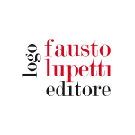 | 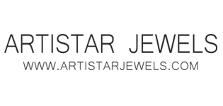 | 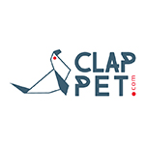
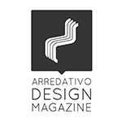 | 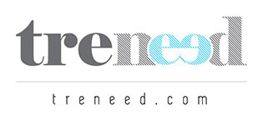 | 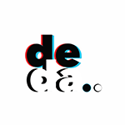
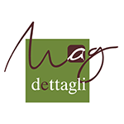 | 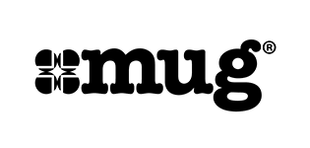 | 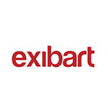
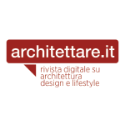 | 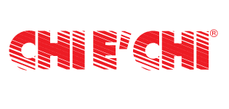
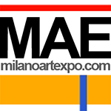 | 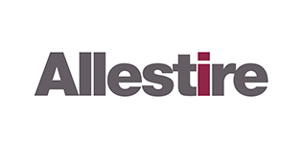 | 